**Software as a Service**

SAAS is a cloud computing model in which applications are hosted by a third-party cloud provider and end-users can use it over Internet, without installing any complex software and hardware equipment. It is a software licensing and distribution model.

SAAS is sometimes known as on-demand software and most particularly Web-based/ Wed-hosted software. Therefore, the applications hosted through SAAS are accessed via web-browsers, irrespective of the versions of systems.

The main characteristics of SAAS are:

* **Multi-tenancy model –**

In SAAS, multiple users have the flexibility to use a single and a common infrastructure of a software application. This means different tenants(users) can use different databases based on their needs.

* **High Availability –**

As customers all-over the world uses these applications at different times in a day, they are designed in a way that they are accessible 24*7 across the world.

* **Elastic Infrastructure –**

The framework on the applications is supposed to be able to increase/ decrease the resources available for a user, since the usage may vary with time. So, tools like Docker, Kubernetes and building a policy engine to receive and react for an event are used to manage the elastic nature of SAAS applications.

* **Data Security –**

The SAAS programs are designed for use by different tenants, so there can be a chance of corruption or unauthorized access of the data. To ensure that the data is protected, it is best to have an encryption storage on data of every individual which cannot be accessed by others. Other ways to secure data include having a good Key Management Framework, being able to integrate with external Key Management Frameworks or with CASB (Cloud Access Security Brokers) system and very strong access controls that are based on different roles.

* **Subscription-based Billing –**

The users using SAAS applications can buy them when necessary and discontinue them later when not needed. This is done as the applications are subscription-based and no license cost, upgrade cost etc. are included. The type of purchase options includes monthly, quarterly, half-yearly, annually or even based on the usage.

**Applications of SAAS:**

SAAS products are regularly marketed to both B2B (Business to Business) and B2C (Business to Customer) users. The primary goals of B2B SAAS are predicting customers moving away from the companies, helping the businesses to maintain customers, etc.

In B2C, SAAS is used by businesses to offer services to customers. The primary goal of B2C SAAS is helping the users feel ease when using their products, site.

|  |  |
| --- | --- |
| **Platform** | **Usage** |
| Salesforce | For Marketing, Service, and Internet of Things |
| Microsoft 365 | To have Connected Experience across multiple Microsoft 365 App surfaces |
| Netflix | To allow the users see videos online based on their subscription |
| Zoom | To hold meetings, conferences online |
| Shopify | To host the ecommerce businesses and market them on-demand |

**Table-1: SAAS in today’s market**

Table-1 describes the popular business and their usage of SAAS to meet their clients and fulfill their needs.

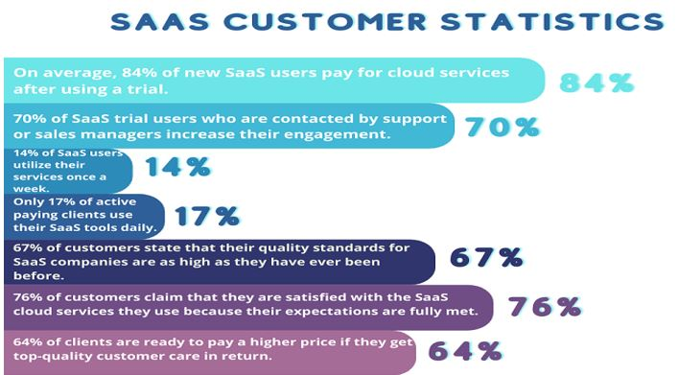

**Figure-1: Analysis of SAAS usage [1]**

Figure-1 shows the statistics of customer usage of SAAS, by how much proportion they use SAAS in their works.

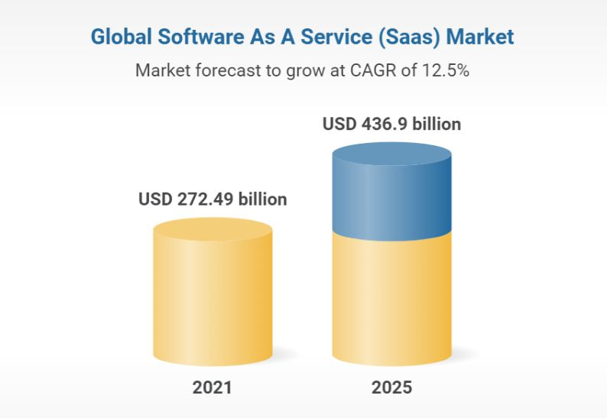

**Figure-2: Forecast of SAAS usage [2]**

From Figure-2, the expected rate of growth of SAAS in global market is 12.5 and by 2015, the use of SAAS in US is expected to almost double that of in 2021.

**Conclusion:**

In conclusion, more organizations are nowadays shifting towards using SAAS applications because there is no need of installing any new software or hardware on their systems and can store large amounts of data in cloud with security being provided.

Also, SAAS enables the businesses to have a fair connection with their customers that helps them withstand in the IT market.

In the future, with more use of SAAS the long-term relationships between customers and service-providers will improve resulting in understanding and providing the growing needs of the users.

With this growing trend, SAAS may address critical challenges of businesses in the coming days like predicting customer churnings, identifying best selling practices and many more.

**References:**

1. <https://thrivemyway.com/saas-stats/> - Thrive my way blog on SAAS stats and trends
2. <https://www.researchandmarkets.com/reports/5319090/software-as-a-service-saas-global-market-report> - Research And Markets report on SAAS in global market

**Please leave the queries and comments in the comment section.**